LAB ASSIGNMENT- 9.3

Name: E. Harini

Enrollment No.: 2503A51L40

Course Code: 24CS002PC215

Course Title: AI Assisted Coding

Lab Number: 8

BRANCH: cse

**Task1:** **Basic Docstring Generation**

* Write python function to return sum of even and odd numbers in the given list.
* Incorporate manual **docstring** in code with Google Style
* Use an AI-assisted tool (e.g., Copilot, Cursor AI) to generate a docstring describing the function.
* Compare the AI-generated docstring with your manually written one.

**1.Prompt:**

Write a Python function that takes a list of integers and returns the sum of even and odd numbers separately.

**2.Code:**



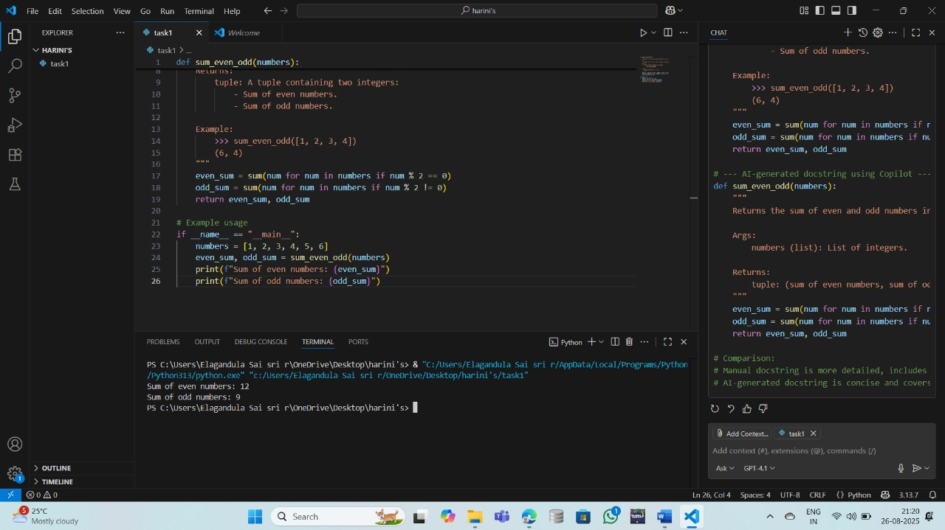

**3.Output:**



**4.Observation:**

The function sum _ even _odd correctly calculates and returns the sum of even and odd numbers from a given list. The output matches the expected results, demonstrating proper use of list comprehensions and tuple return values.

**Task2:** **Automatic Inline Comments**

* Write python program for **sru _ student** class with attributes like name, roll no., hostel_ status and **fee_ update** method and **display _details** method.
* Write comments manually for each line/code block
* Ask an AI tool to add inline comments explaining each line/step.
* Compare the AI-generated comments with your manually written one.

**1.Prompt**:

Create a Python class named sru_student with attributes for name, roll number, hostel status, and fee status .

**2.Code:** 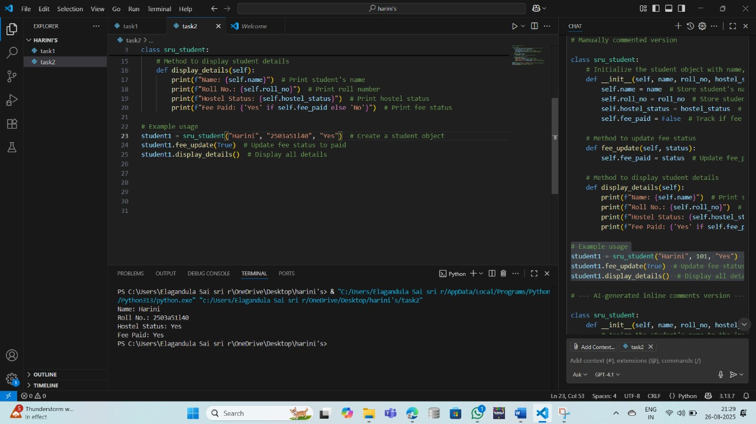

**3.Output**:



**4.Observation:**

The [sru _student](vscode-file://vscode-app/c:/Users/Elagandula%20Sai%20sri%20r/AppData/Local/Programs/Microsoft%20VS%20Code/resources/app/out/vs/code/electron-browser/workbench/workbench.html" \o ") class is well-structured, with attributes for name, roll number, hostel status, and fee status. The methods [fee_update](vscode-file://vscode-app/c:/Users/Elagandula%20Sai%20sri%20r/AppData/Local/Programs/Microsoft%20VS%20Code/resources/app/out/vs/code/electron-browser/workbench/workbench.html" \o ") and [display_details](vscode-file://vscode-app/c:/Users/Elagandula%20Sai%20sri%20r/AppData/Local/Programs/Microsoft%20VS%20Code/resources/app/out/vs/code/electron-browser/workbench/workbench.html" \o ") work as intended, allowing for fee status updates and displaying all student details clearly.

**Task3:**

Write a Python script with 3–4 functions (e.g., calculator: add, subtract, multiply, divide).

* Incorporate manual **docstring** in code with NumPy Style
* Use AI assistance to generate a module-level docstring + individual function docstrings.
* Compare the AI-generated docstring with your manually written one.

**1.Prompt**:

Write a Python script with four functions: add, sub, mul, and div. Each function should take two arguments and return the result of the corresponding arithmetic operation .

**2.Code:** 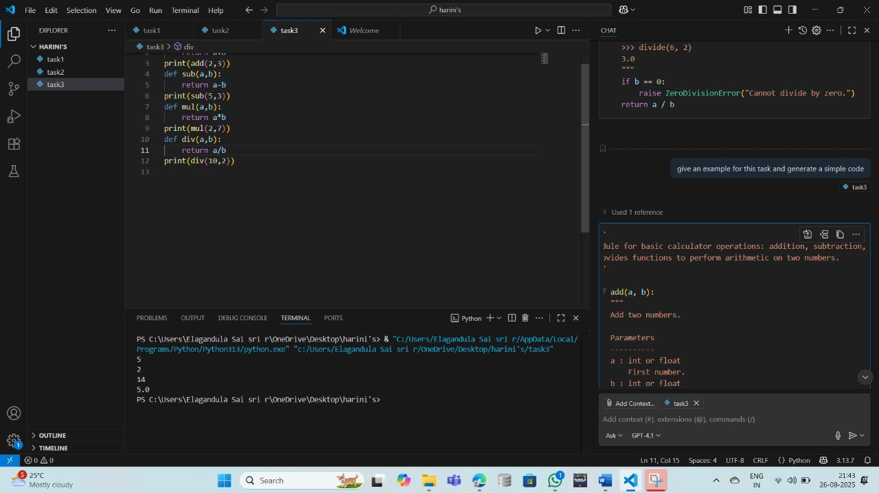

**3.Output:**



**4.Observation:**

The calculator script implements basic arithmetic functions: addition, subtraction, multiplication, and division. Each function returns the correct result for sample inputs, and the printed outputs confirm the accuracy of the operations.